**PROJECT PAHSE-2 (PART a)**

***Handling Deletion –***

**using Mongoose Middleware**

**we can use 2 middlewares:**

* Pre – run before the query is executed
* Post – run after the query is executed

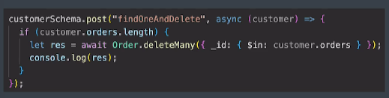

**PROJECT PAHSE-2 (PART b)**

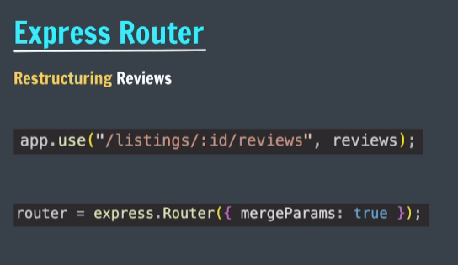

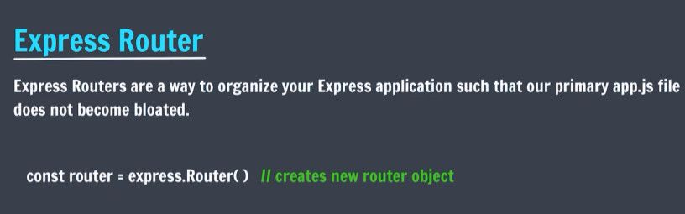

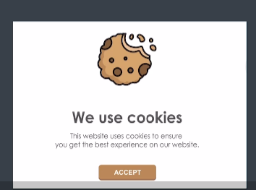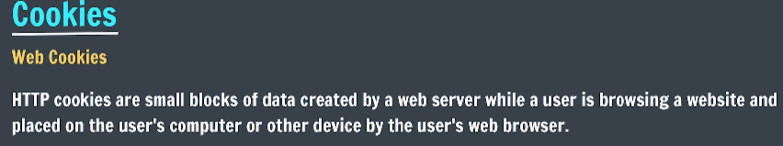

**Cookie work session track.**

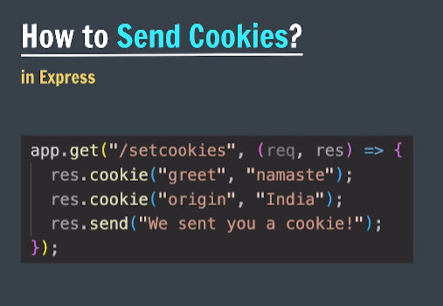

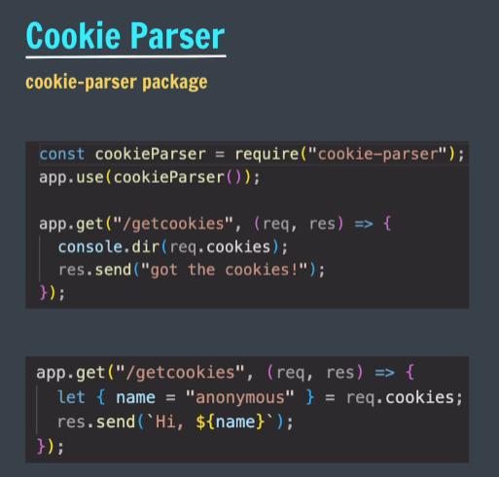

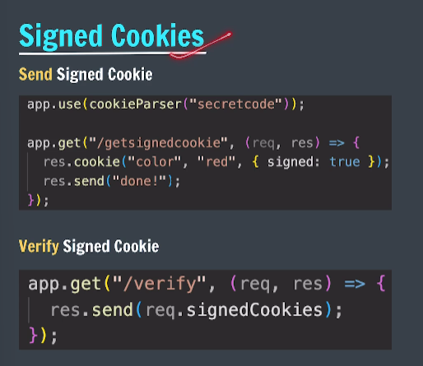

**PROJECT PAHSE-2 (PART c)**

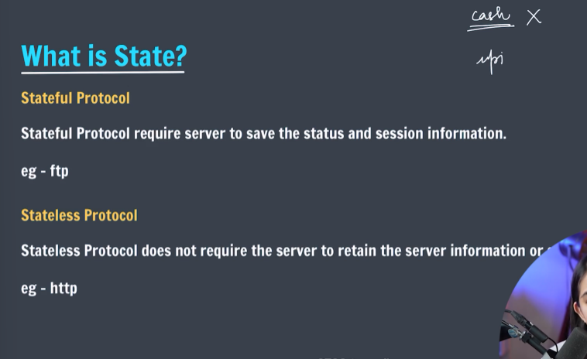

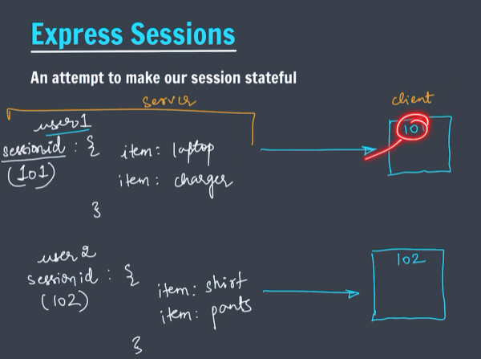

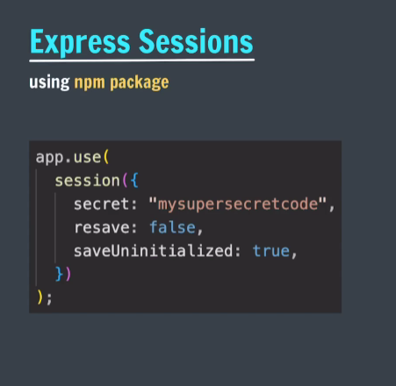

***Connect-flash –***

The flash is a special area of the session used for storing messages. Messages are written to the flash and cleared after being displayed to the user.

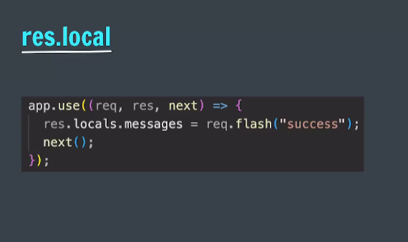

**PROJECT PAHSE-2 (PART d)**

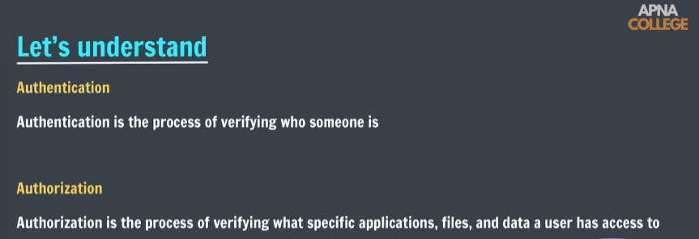

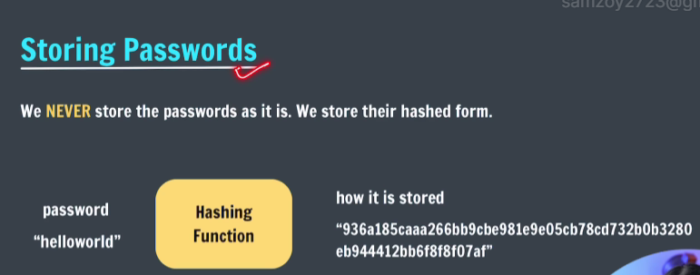

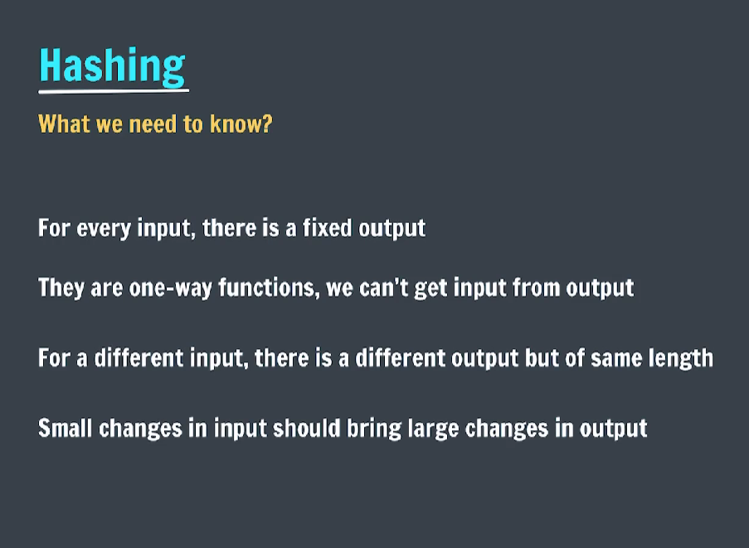

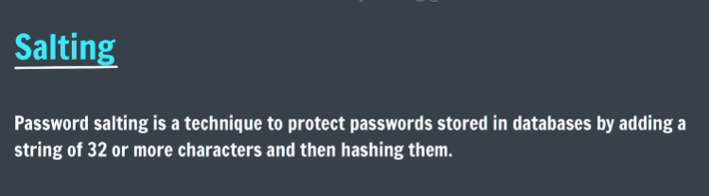

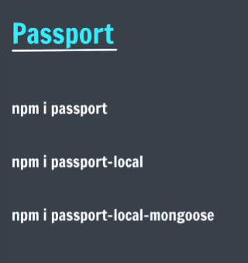

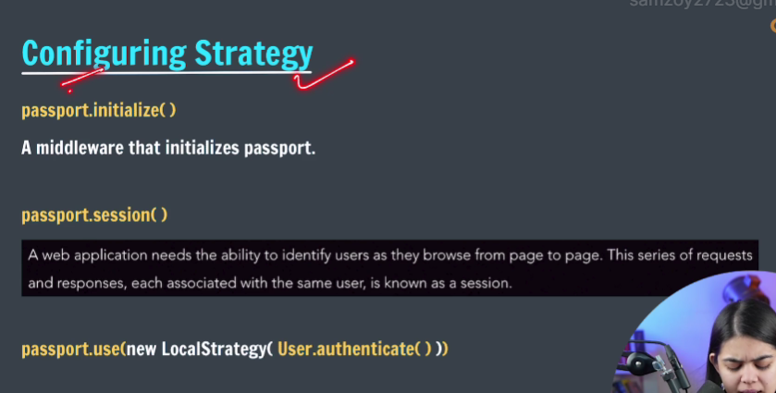

**PROJECT PAHSE-2 (PART e)**

